
MATHEMATICS P2

NOVEMBER 2011
NATIONAL
SENIOR CERTIFICATE
GRADE 12

MARKS: 150

TIME: 3 hours

This question paper consists of 12 pages, 1 diagram sheet and 1 information sheet.

INSTRUCTIONS AND INFORMATION

Read the following instructions carefully before answering the questions.

1.  2.  3.  4.  5. | This question paper consists of 12 questions.  Answer ALL the questions.  Clearly show ALL calculations, diagrams, graphs, et cetera which you have used in determining the answers.  Answers only will not necessarily be awarded full marks.  You may use an approved scientific calculator (non-programmable and non-graphical), unless stated otherwise.

6.  7.  8. | If necessary, round off answers to TWO decimal places, unless stated otherwise.  Diagrams are NOT necessarily drawn to scale.  ONE diagram sheet for QUESTION 4.2 is attached at the end of this question paper. Write your centre number and examination number on this sheet in the spaces provided and insert the sheet inside the back cover of your ANSWER BOOK.

9.  10.  11. | An information sheet, with formulae, is included at the end of this question paper.  Number the answers correctly according to the numbering system used in this question paper.  Write neatly and legibly.

QUESTION 1

Fifteen members of a basketball team took part in a tournament. Each player was allowed the same amount of time on the court. The points scored by each player at the end of the tournament are shown below.

27 | 28 | 30 | 32 | 34 | 38 | 41 | 42 | 43 | 43 | 44 | 46 | 53 | 56 | 62

1.1 | Determine the median of the given data. |  | (1)

1.2 | Determine the interquartile range for the data. |  | (3)

1.3 | Draw a box and whisker diagram to represent the data. |  | (3)

1.4 | Use the box and whisker diagram to comment on the points scored by the players in this team. |  | (2)  [9]

QUESTION 2

The scores for 8 golfers who played a single round of golf on the same golf course are shown below.

69 | 71 | 75 | 74 | 78 | 70 | 72 | 71

2.1 | Calculate the mean score. |  | (2)

2.2 | Calculate the standard deviation for the data. |  | (2)

2.3 | How many golfers' scores lie outside one standard deviation of the mean? |  | (2)  [6]

QUESTION 3

A group of 8 learners was randomly selected from a class. The performance of these learners in a standardised test (which counted 150 marks) and the average number of hours they spend watching TV each week was recorded. The data is represented in the scatter plot below.
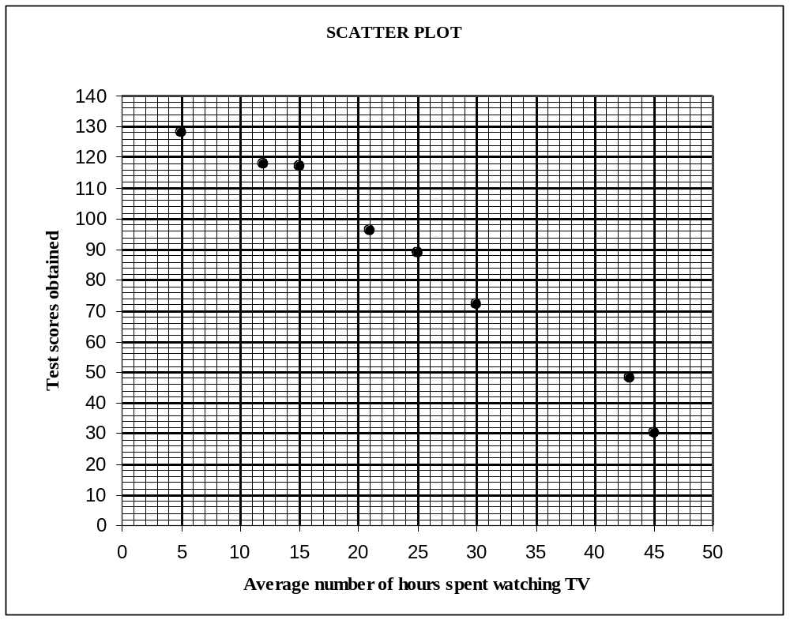

3.1 | What is the lowest test score for this group of learners? |  | (1)

3.2 | Does the data display a linear, quadratic or exponential relationship? Justify your choice. |  | (2)

3.3 | What conclusion can be reached about the learners' test scores and the average number of hours they spend watching TV? |  | (1)

3.4 | Another learner from the class watches 35 hours of TV per week. Using the given information, predict his/her performance in the test. |  | (2)  [6]

QUESTION 4

Thirty learners were asked to answer a question in Mathematics. The time taken, in minutes, to answer the question correctly, is shown in the frequency table below.

TIME, T (IN MINUTES) | NUMBER OF LEARNERS
1 ≤ t < 3 | 3
3 ≤ t < 5 | 6
5 ≤ t < 7 | 7
7 ≤ t < 9 | 8
9 ≤ t < 11 | 5
11 ≤ t < 13 | 1

4.1 | Construct a cumulative frequency table for the data. |  | (3)

4.2 | Draw a cumulative frequency graph (ogive) of the above data on the grid provided on DIAGRAM SHEET 1. |  | (4)

4.3 | If a learner answers the question correctly in less than 4 minutes, then he/she is classified as a 'gifted learner'. Estimate the percentage of 'gifted learners' in this group. |  | (2)  [9]

QUESTION 5

In the diagram below, PQRS is a rectangle with vertices P(– 4 ; 0), Q(4 ; a), R(6 ; 0) and S. Q lies in the first quadrant.
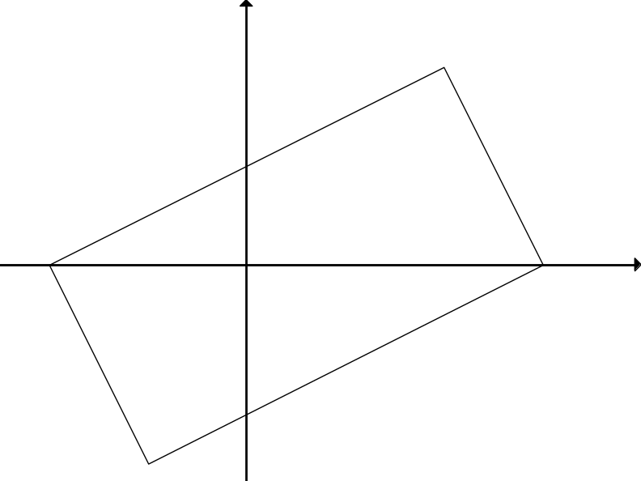
S
P(– 4 ; 0)
Q(4 ; a)
R(6 ; 0)
y
x
O

5.1 | Show that a = 4. |  | (4)

5.2 | Determine the equation of the straight line passing through the points S and R in the form 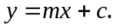 |  | (4)

5.3 | Calculate the coordinates of S. |  | (4)

5.4 | Calculate the length of PR. |  | (2)

5.5 | Determine the equation of the circle that has diameter PR. Give the equation of the circle in the form 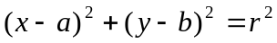. |  | (3)

5.6 | Show that Q is a point on the circle in QUESTION 5.5. |  | (2)

5.7 | Rectangle PQRS undergoes the transformation 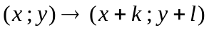where k and l are numbers. What is the minimum value of k + l so that the image of PQRS lies in the first quadrant (that is, x ≥ 0 and y ≥ 0)? |  | (3)  [22]

QUESTION 6

The circle with centre B(–1 ; 1) and radius 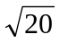 is shown. BC is parallel to the y-axis and CB = 5. The tangent to the circle at A passes through C.
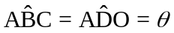

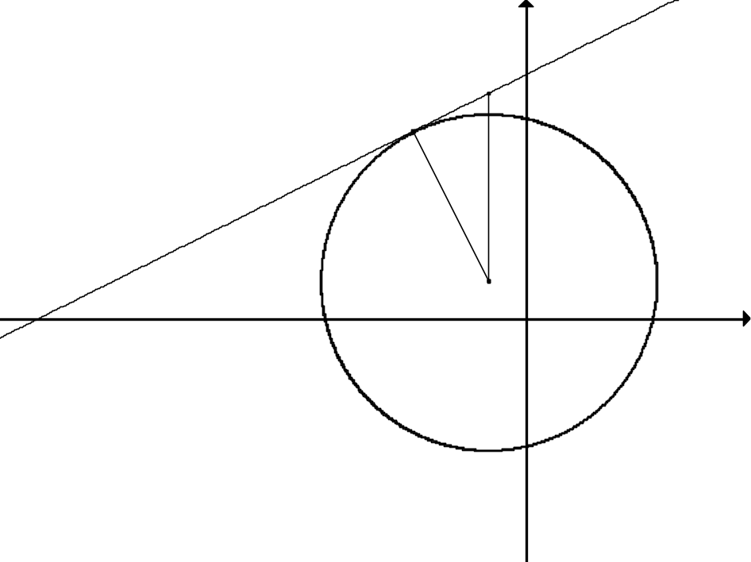
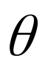
x
y
D
A
C
B
O
F

6.1 | Determine the coordinates of C. |  | (2)

6.2 | Calculate the length of CA. |  | (3)

6.3 | Write down the value of tan . |  | (1)

6.4 | Show that the gradient of AB is – 2. |  | (2)

6.5 | Determine the coordinates of A. |  | (6)

6.6 | Calculate the ratio of the area of ABC to the area of ODF. Simplify your answer. |  | (5)  [19]

QUESTION 7

7.1 | The following transformation is applied to all points:  - Firstly, a point is translated by 4 units to the right.  - Then it is rotated through 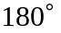 about the origin.  Write down the general rule that represents the above transformation in the form 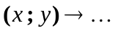 |  | (4)

7.2 | Reflect the circle with centre C(– 5 ; – 2) and radius of 4 units about the line y = x. Give the equation of the new circle in the form 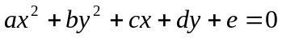. |  | (4)  [8]

QUESTION 8

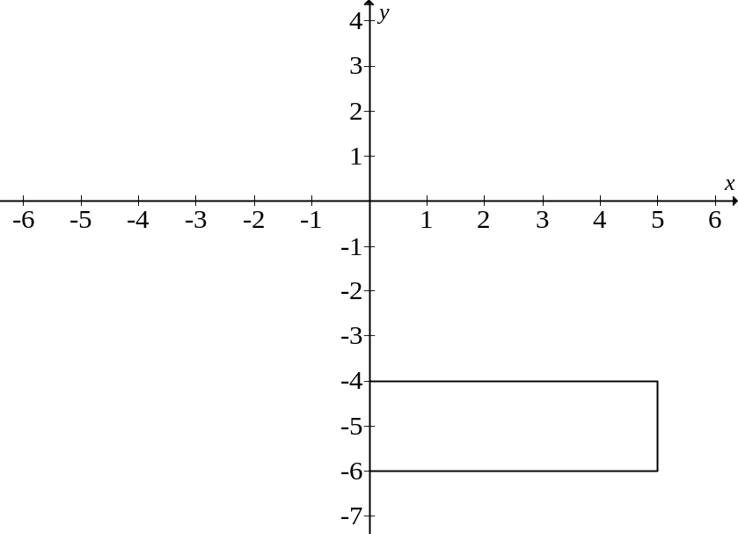
A
B
C
D
O

In the diagram, A is the point (0 ; – 4), AB = 2 and AD = 5. Rectangle ABCD is rotated about the origin to form rectangle A/B/C/D/. After the rotation the image of point A is 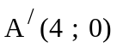.

8.1 | Describe the transformation fully in words. |  | (2)

8.2 | Write down the coordinates of 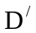. |  | (2)

8.3 | If ABCD is reflected about the line x = – 1 to form EFGH, write down the coordinates of G, the image of C. |  | (2)

8.4 | If ABCD is enlarged by a scale factor of  through the origin to form MNPR, determine the value of area ABCD area MNPR. |  | (3)  [9]

QUESTION 9

9.1 | If tan A = 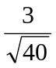 and 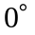<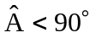, determine the values of the following with the aid of a sketch and without using a calculator. Leave your answers in surd form, if necessary.

 | 9.1.1 | cos A |  | (3)

 | 9.1.2 | sin (180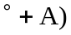 |  | (2)

9.2 | Without using a calculator, determine the value of the following expression:  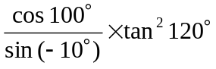 |  | (6)

9.3 | P(4 ; 3) and M(a ; b) are points on a circle with the origin as centre.  Q and R are x-intercepts of the circle.
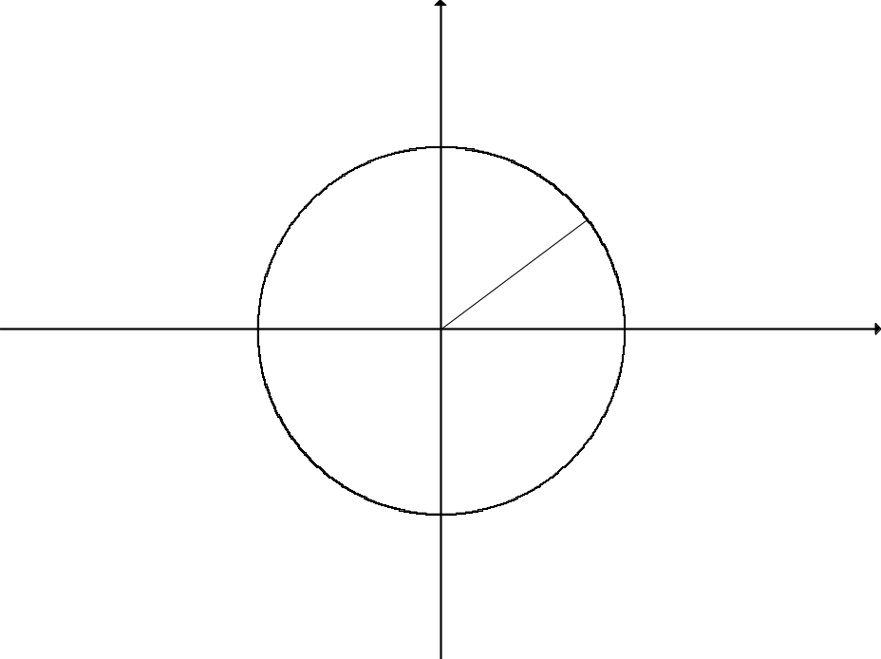
P(4 ; 3)
R
O
M(a ; b)
Q
x
y

 | 9.3.1 | Write down the numerical value of 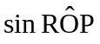. |  | (2)

 | 9.3.2 | Calculate the size of 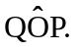 |  | (2)

 | 9.3.3 | If obtuse 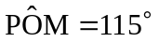, calculate the value of a, the x-coordinate of M, correct to TWO decimal places. |  | (3)  [18]

QUESTION 10

The graphs of the functions = a tan x and g(x) = b cos x for 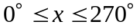 are shown in the diagram below. The point (225° ; 2) lies on f. The graphs intersect at points P and Q.

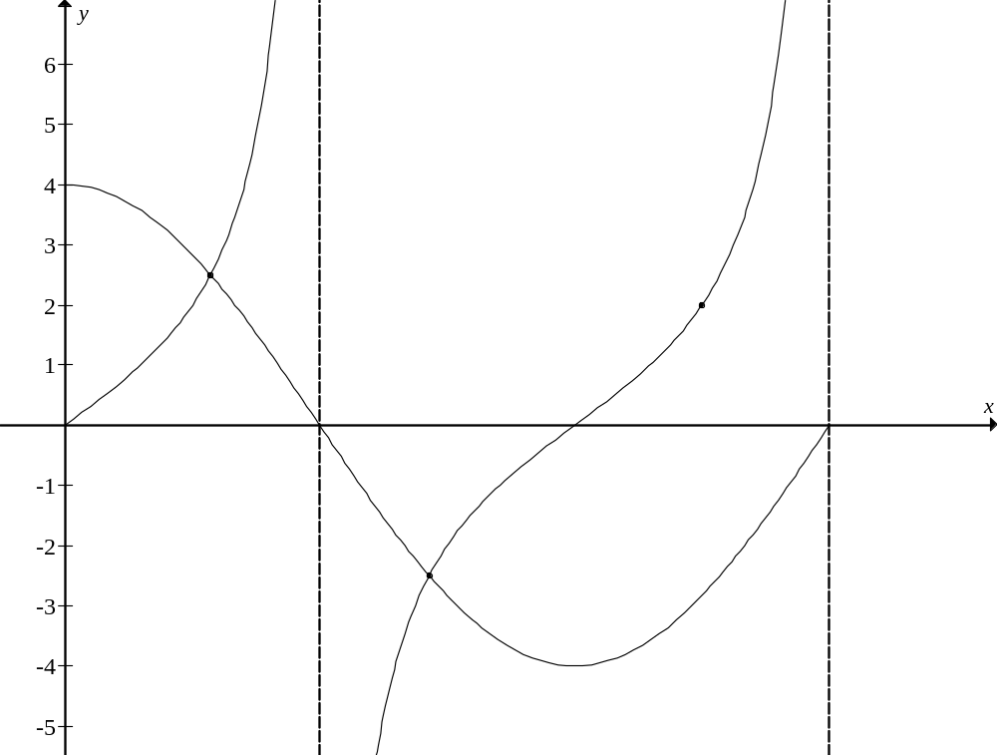
f
g
P
Q
(225° ; 2)
f
180°
270°

0
90°

10.1 | Determine the numerical values of a and b. |  | (4)

10.2 | Determine the minimum value of g(x) + 2. |  | (2)

10.3 | Determine the period of f 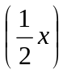. |  | (2)

10.4 | Show that, if the x-coordinate of P is , then the x-coordinate of Q is (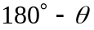). |  | (4)  [12]

QUESTION 11

The figure below represents a triangular right prism with BA = BC = 5 units, 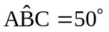 and 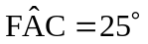.

F
B
A
E
C
D

11.1 | Determine the area of ΔABC. |  | (2)

11.2 | Calculate the length of AC. |  | (3)

11.3 | Hence, determine the height FC of the prism. |  | (3)  [8]

QUESTION 12

12.1 | Prove that, if 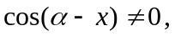  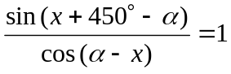. |  | (3)

12.2 | Determine the general solution of 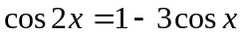. |  | (7)

12.3 | 12.3.1 | Prove that, for angles A and B,  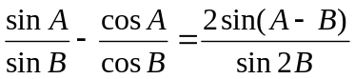 |  | (4)

 | 12.3.2 | Hence, or otherwise, without using a calculator, show that:

 |  | (a) | 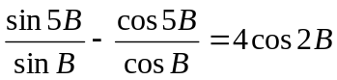 |  | (3)

 |  | (b) | 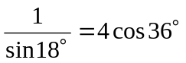 |  | (3)

 |  | (c) | sin 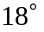 is a solution of the cubic equation 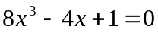 |  | (4)  [24]

TOTAL: |  | 150

CENTRE NUMBER:

EXAMINATION NUMBER:

DIAGRAM SHEET 1

QUESTION 4.2

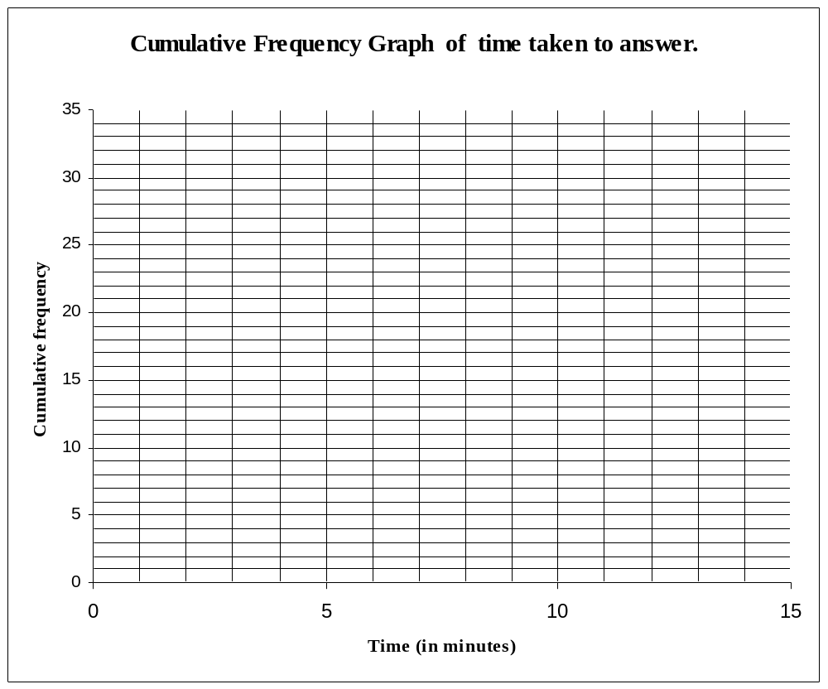
CUMULATIVE FREQUENCY GRAPH OF TIME
TAKEN TO ANSWER THE QUESTION
Cumulative frequency
Time (in minutes)

INFORMATION SHEET: MATHEMATICS
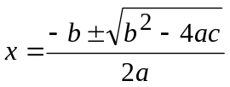
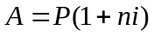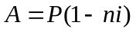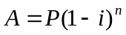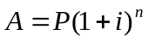
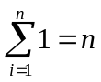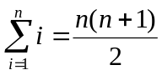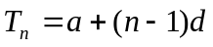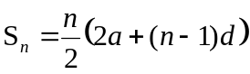
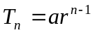 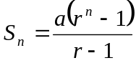 ; 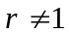 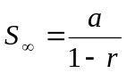; 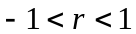
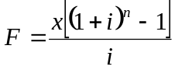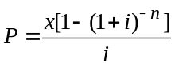
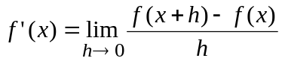
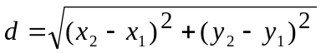 M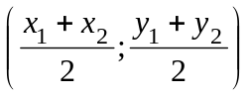
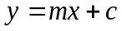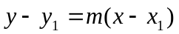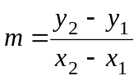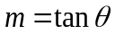
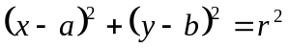
In ΔABC: 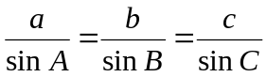 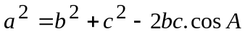 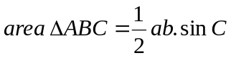
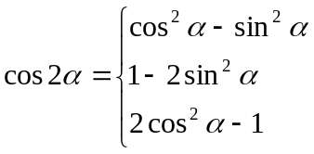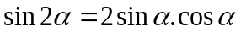
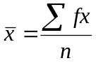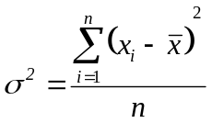
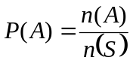 P(A or B) = P(A) + P(B) – P(A and B)
